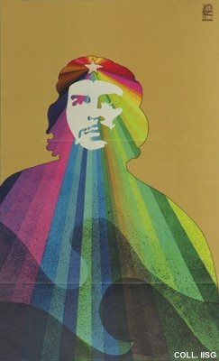 |  | Alfredo Rostgaard, 1969  Che  Publisher: OSPAAAL  (Offset, 53x32.5 cm., inv.nr. BG D12/852)  Heroic, idealized portraits like this one are made only from Che Guevara, and only after his death. Fidel Castro and the other leaders are deliberately portrayed as ordinary human beings

