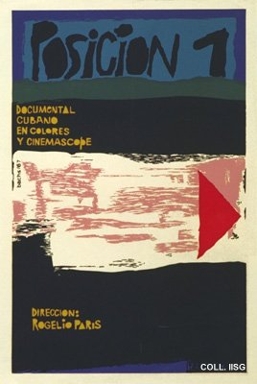 |  | Eduardo Muñoz Bachs, 1967  Position 1  Publisher: ICAIC  (Silkscreen, 76.5x51 cm., inv.nr. BG E3/912, coll. Martinez)  Poster for a Cuban documentary film, very unusual for the absence of figurative elements

